User manual of BS-858 electric bed
Grateful for using Bossay’s electric bed, pls read this manual carefully before operating.
- Product summarize
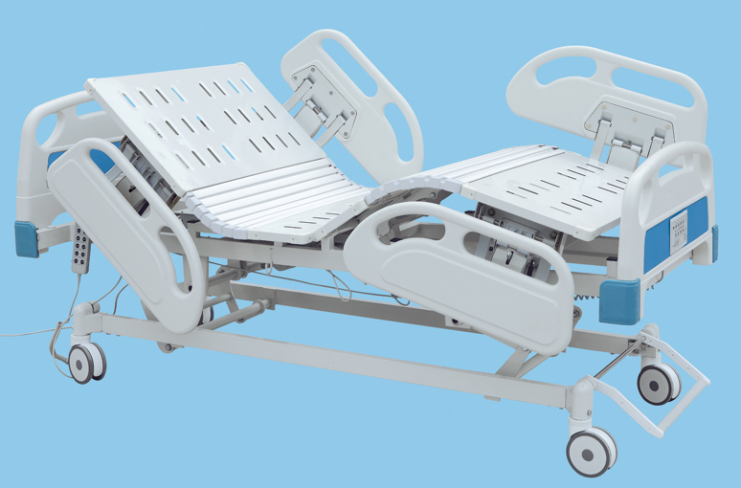

  - Product composition:
Overall size:2120*1000*450/700mm
Material： ▪ ABS head and foot board,antisepsis,anti-oxidation,generous in appearance. ▪ The bed platform is made of cold roll steel sheet,shaped at one time; ▪ The frame is welded by steel tube,stable and reliable;surface treatment:electrostatic powder coating ▪ PP tuck away siderails,generous in appearance,stable and easily operated. ▪ The system uses Taiwan Timotion ,the safety voltage motor
Standard Configuration:
▪ Advanced medical motor system(4 pcs motors,1 pcs control box,1 pcs handset)
▪ Urine hooks,I.V drip ▪ Bed board with flexible connection ▪ Central-controlled castor brake system

- Working status

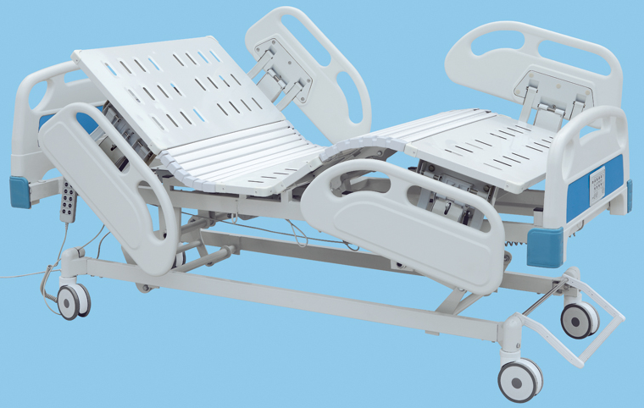
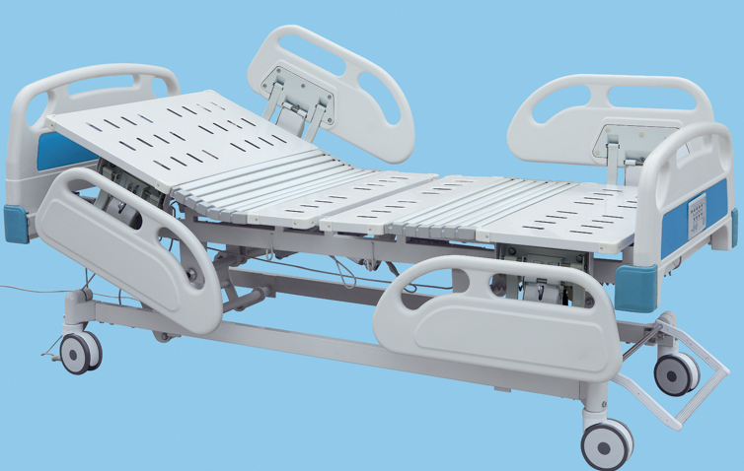
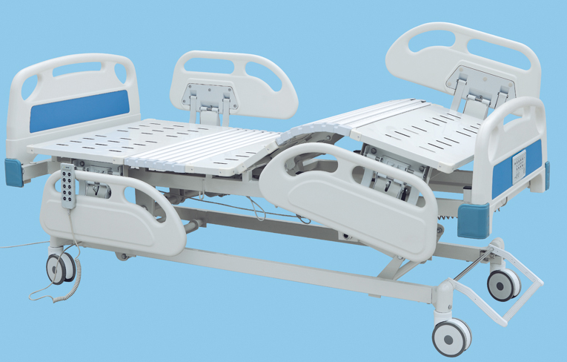
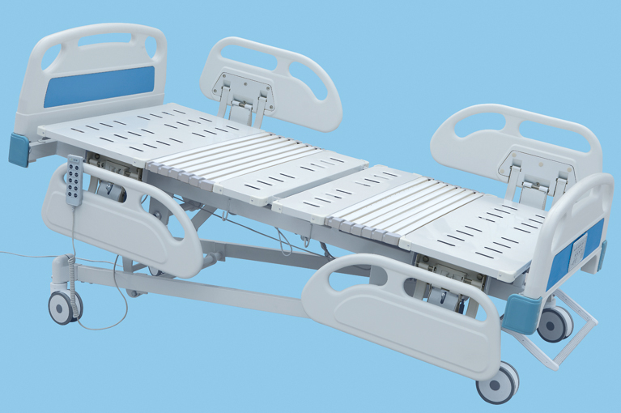
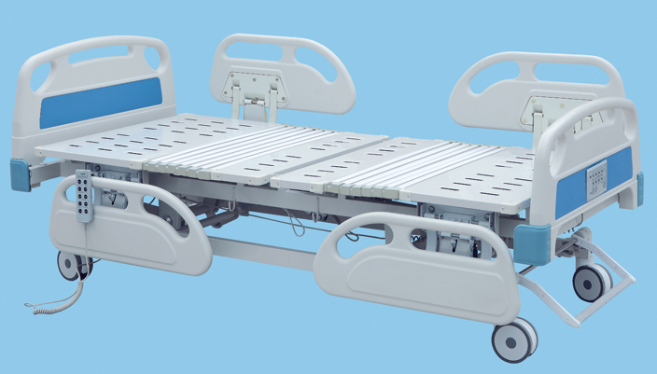
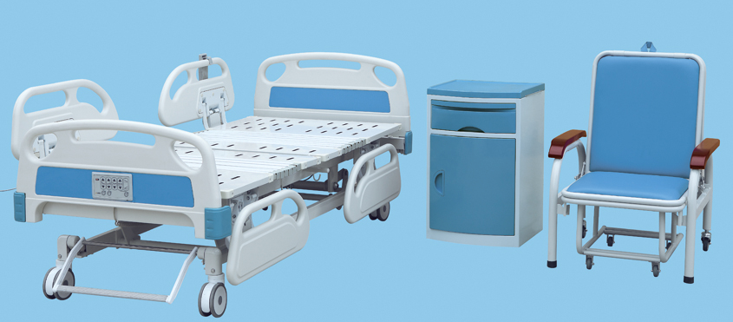

BS-858 Luxurious Electric Bed with Five Functions
Product structure characteristics and working principle introduction:
- Electric Bed consist of five parts:bed board(include back board,fixation board,leg board,baseboard),bed frame,ABS bed head board and foot board,PP guardrail and base support.
- Controller.Lifting height of bed surface,Conditioning back board and leg board angle
- Hospital bed with PP guardrail,protect patients safety.
Name | Description
Bed Frame | Consist of carbon steel pipe,carbon steel angle and carbon steel plate  Using carbon steel pipe 60*30*1.5、50*50*1.5  Carton steel angle 30*30*2.5
Bed Surface | Using cold rolled steel 1.1mm steel stamping,stretch forming,  bonding forming
Bed head board and foot board | ABS bed head board and foot bord  Color:Blue
Castor | Central-controlled system,lock the four coaster at the same time
Motor | Imported from TaiWan
Optional:
Side rail | PP side rail
I.V Stand | Urine hooks 4 pieces,  Height adjustable from 900mm to 1700 mm  Material:Stainless Steel
Product Feature and technical parameters:
bed board size | 1900*900mm
Height adjustable | from :450 to 700mm
Back-rest lifting angle | 0～80°(±5°)
Knee-rest lifting angle | 0~40°(±5°)
environmental requirement | ambient temperature:5℃～40℃  relative temperature≤80℃  atmospheric pressure 86～106kpa
Power Supply | AC220V,50HZ
controller voltage | DC24V
Overall size | L2100*W910*H450mm
warranty period | Under the condition of compliance with products storage and operating requirement,from the date of delivery within 12 months, as a result of product quality problems caused by equipment failure,repair and replacement part for free

Installation, commissioning:
- After unpacking check the packing list
- Put the bed frame to its place
- Push the hospital bed should be light and flexible,with the feet on the break roller,Raise
the brake can loosen the roller,push the bed.
- Press on the bed board raise up key,bed board rise,loosen the key, bed board reach the aim height
And stop movement;Press on the bed board fall key,bed board go down;When it reach the highest or lowest position(raise up to 700mm,fall up to 450mm),motor will stop moving.
- Press on the back board raise up key,back board rise,loosen the key,back board reach the aim height;Press on the back board fall key,back board go down;When it reach the highest or lowest position(raise up to 80°,fall up to 0°),motor will stop moving.
- Press on the leg board raise up key,leg board rise,leg board reach the aim height;Press on the leg board fall key,leg board go down;when it reach the highest or lowest position(raise up to 40°,fall up to 0°),motor will stop moving.
- Press on the Trendelenburg raise up key,tail of hospital bed go up.Press on the
trendelenburg fall key,tail of the hospital bed go down.When it reach the highest or lowest position(raise up to 12°,fall up to 0°),motor will stop moving.
8.Press on the Rev.Trendelenburg raise up key,tail of hospital bed go up.Press on the
Rev.trendelenburg fall key,tail of the hospital bed go down.When it reach the highest or lowest position(raise up to 12°,fall up to 0°),motor will stop moving.

Notes:
- Operate the hospital bed by the special training medical staff
- Be sure not to self-operated the hospital bed by patient,avoid damage.
- Use spay disinfect the hospital bed
- Hospital bed dynamic security bearing ≤180kg,Static security bearing≤250kg,
prohibit over load
- Preventive Maintenance at a fixed time,avoid the mechanical failure
- Drive system should be maintenance for every two year.
- After fixed the position,step on the brake roller,avoid the beds moving.
- When nobody use the hospital bed,put the bed board into the lowest position,and cut off
The power supply.
Transportation & Storage:
- Transportation requirement as stipulated in the contract
- Storage requirement:relative temperature≦80º,No corrosive gas, room with good
Ventilation
Notes,Caution and Instruction:
- Hospital bed dynamic security bearing≤180kg,Static security bearing250kg
- Should be brake two rollers when stop at any place,ensure the bed will not move.
- Ensure the bedboard be setted to the lowest position,when nobody use the bed.
- Try to reduce the load when adjust the angle
- Check and maintain the bed every year,oil renewing
- Daily cleaning maintenance,use neutral synthetic washing agent,wet cloth wipe,and
Dry cloth wipe clean
- Do not contact with strong acid, strong alkali, prevent erode
- Put the bed into lowest position when nobody watch the patient
- Do not press the power supply cord ,when the hospital bed is moving,avoid
The insulation broken;No collision,extruding bed head board and foot board when
moving the beds.
Maintenance and storage method：
- Do not overload,frequently regulation Angle
- Periodic inspection according to the operating environment,when abnormal voice,should check the reason and removal the fault.
- When the brake roller broken,should change the castor.
- Product should be stored in relative humidity of no more than 80º,No corrosive gas and
in good indoor ventilation
- People can not sit on the bed head board and foot board,avoid the Security incidents
- When back board and head board raise up,the max load is 25KG,avoid it out of shape.
